**Name: Jana Caresse Llera**

1. Display all columns from tbl_employees.
2. Display only the firstname and lastname of all employees.
3. Show firstname, lastname, and salary of all employees.
4. Find all employees whose firstname starts with **'S'**.
5. Find all employees whose lastname ends with **'off'**.

SELECT * FROM tbl_employees WHERE lastname LIKE '%off';

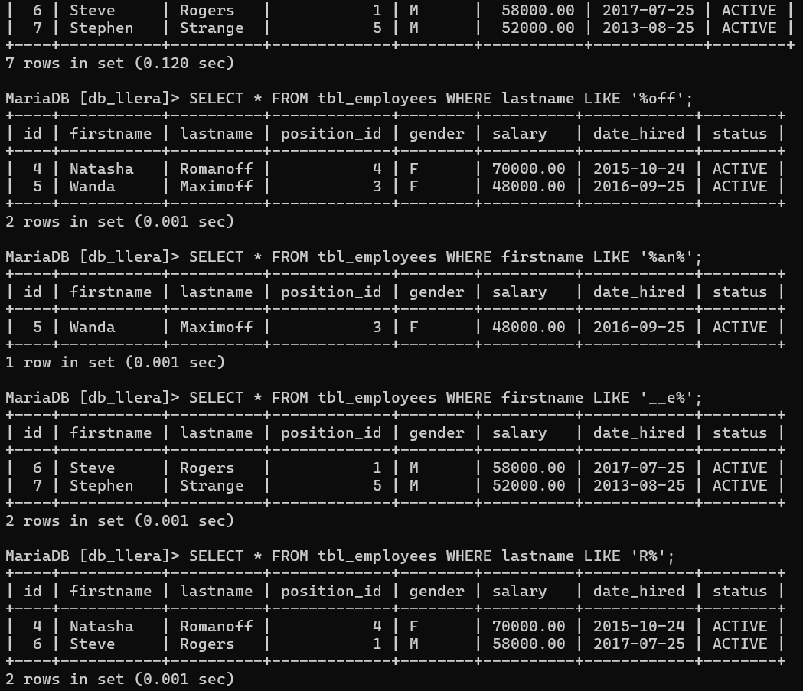

1. Find employees with firstname containing **'an'**.

SELECT * FROM tbl_employees WHERE firstname LIKE '%an%';



1. Find employees whose firstname second letter is **'e'**.

SELECT * FROM tbl_employees WHERE firstname LIKE '__e%';



1. Find employees whose lastname starts with **'R'**.

SELECT * FROM tbl_employees WHERE lastname LIKE 'R%';



1. Show distinct position_id values.

SELECT DISTINCT position_id FROM tbl_employees;

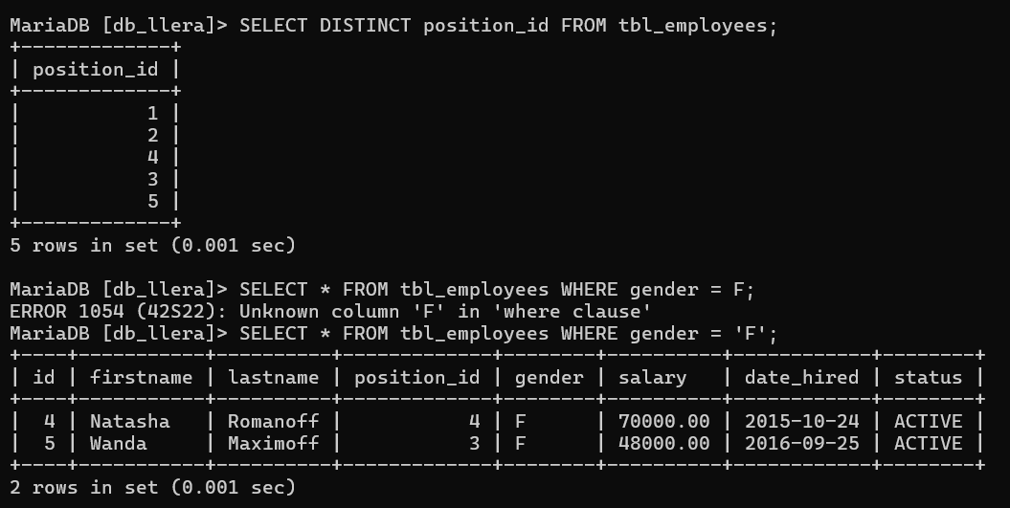

1. Show distinct gender values from the table.

SELECT * FROM tbl_employees WHERE gender = 'F';



SELECT * FROM tbl_employees WHERE gender = 'M';

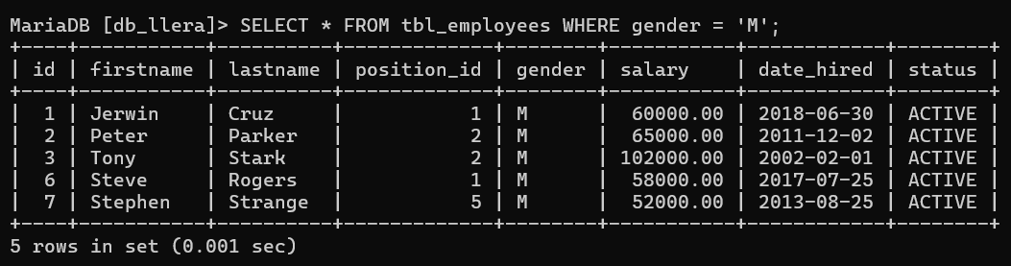

1. Display all employees with a salary greater than **60,000**.
2. Display all employees who were hired before **2015-01-01**.
3. Display employees with gender = 'F'.
4. Show employees whose status is ACTIVE.
5. Display employees whose salary is between **50,000** and **70,000**.
6. Display employees sorted by firstname in ascending order.
7. Display employees sorted by salary in descending order.
8. Show employees sorted by date_hired (oldest first).
9. Count how many employees are in each position_id.
10. Count how many employees are grouped by gender.
11. Find the total salary per position_id.
12. Show position_id groups having more than **1 employee**.
13. Show gender groups where the average salary is above **60,000**.
14. Show only the **first 3 employees** from the table.
15. Show **3 employees starting from the 3rd record** in the table.